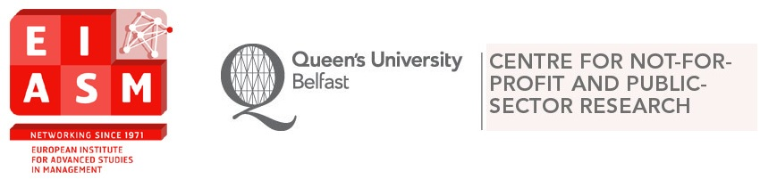

11th EIASM Workshop on the Challenges of Managing the Third Sector
14-15 June 2017

Wednesday, June 14
8.30-9.15 Registration: Foyer, Riddel Hall, Queen’s Management School, 185 Stranmillis Road, Belfast
9.15-9.30 Welcome by Noel Hyndman: Courtyard, Riddell Hall

9.30-11.00 Session 1. Chair: Marc Jegers
Carolyn Cordery, Dalice Sim: The functions and finances of mutual-benefit and public-benefit entities: are different regulatory stances appropriate?
Danielle McConville: Outcome reporting and transparency in UK charities: views from the front line.
Mohammed Mohi Uddin: Changes in strategic responses to external institutional pressures for accountability: a large development NGO perspective.

11.00-11.30 Coffee Break

11.30-12.30 Session 2. Chair: Bernd Helmig
Abel Diaz, Nikolay Dentchev, Philippe Eiselein: Building up a social entrepreneurial support ecosystem from universities: a case study of the VUB chair or social entrepreneurship.
Ralph Kober, Janet Lee, Juliana Ng: A different point of view: the perceptions of Australian not-for-profit managers and financial statement preparers on a common conceptual framework, sector neutrality and the usefulness of financial information.

12.30-14.00 Lunch: Courtyard, Riddell Hall

14.00-15.00 Session 3. Chair: Irvine Lapsley
Mariannunziata Liguori, Ciaran Connolly, Noel Hyndman: Legitimating change before it happens: introducing the new Statement of Recommended Practice in the UK and the Republic of Ireland.
Galina Goncharenko: Accounting information demands of institutional donors form a human rights organization in Norway: parallel reporting realities.

15.00-15.30 Coffee Break

15.30-16.30 Session 4. Chair: Noel Hyndman
Maren Rottler, Hellen Gross: Internal marketing influences volunteer outcomes in arts organizations: a multiple mediation analysis.
Isabella Nolte: Global-local partnerships: a review of collaborative performance in a social context.

19.15 Drinks Reception and Workshop Dinner – Cutters Wharf, Lockview Road, Belfast

Thursday, June 15

9.30-10.30 Session 5. Chair: Irvine Lapsley
Simon Cornée, Marc Jegers, Ariane Szafarz: A theory of social finance.
Silke Boenigk, Aaron Kremer: Role-changing behaviors and outcomes of public and nonprofit organizations within the 2015 refugee crisis: a study of positive deviance.

10.30 -11.00 Coffee Break

11.00-12.00 Session 6. Chair: Bernd Helmig
Donatella Casale: Jewish charities: too many or too big? A cross-sectional analysis of income concentration trends in the jewish charitable sector in England and Wales between 1995 and 2015.
Witold Nowak, Michal Nowosielski: The state, diaspora policy and immigrant organizations – a study of transformation outcomes.

12.00-13.30 Lunch: Courtyard, Riddell Hall

13.30-15.00 Session 7. Chair: Noel Hyndman
Anne Marie Ward, John Forker: Institutions, female leadership selection and the glass cliff.
Alexander Pinz, Marina Friedrich, Julia Thaler: The relationship between staff turnover and the performance of microfinance organizations.
Alasdair Rutherford, Tom McKenzie: Career concerns versus shared values: an empirical investigation.

15.00-15.30 Coffee Break

15.30-17.00 Session 8. Chair: Marc Jegers
Farooq Mahmood, Motivators for financial statements misreporting in the UK charities’ context.
Anna Scheer, Irvine Lapsley: Opacity and disingenuity: the governance of FIFA.
Per Stale Knardal: Budget control and perceived environmental uncertainty – the case of Norwegian festivals.

17.00 Closing

Note: per paper – 20 minutes presentation, 10 minutes discussion.

